**Experiment 2 - Creating Amazon EC2 Instances - Creating a LAMP Instance in the AWS CLI**

**AIM:** To create a LAMP instance in the AWS CLI.

**PROCEDURE:**

1. Firstly, type sudosu to become the root user.
2. To update all the packages in your instance type “yum update -y”.

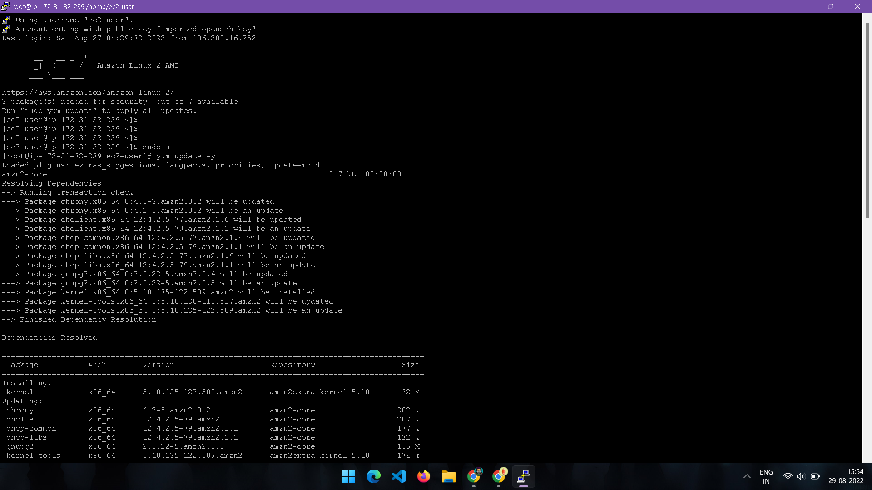

1. To install Apache server in linux, type “yum install httpd”.

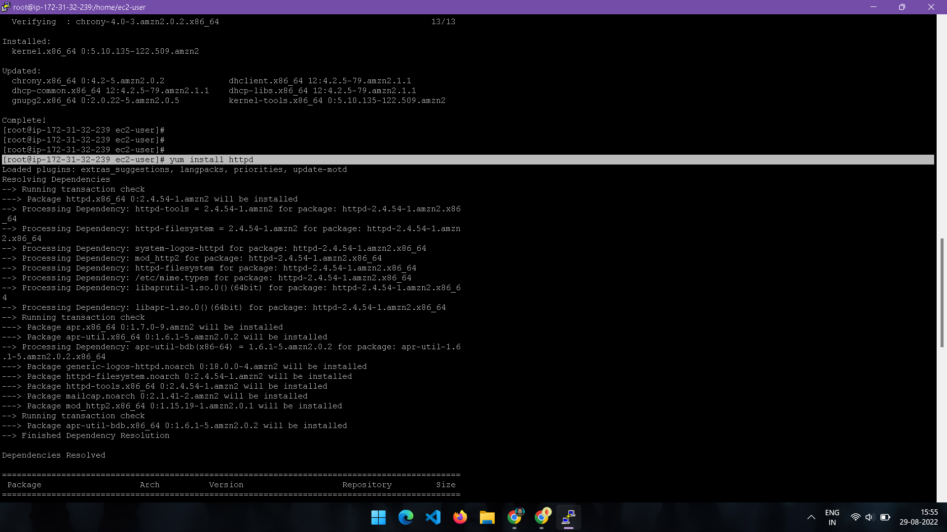

1. To install mysql or mariadb type “yum install mariadbmariadb-server”.

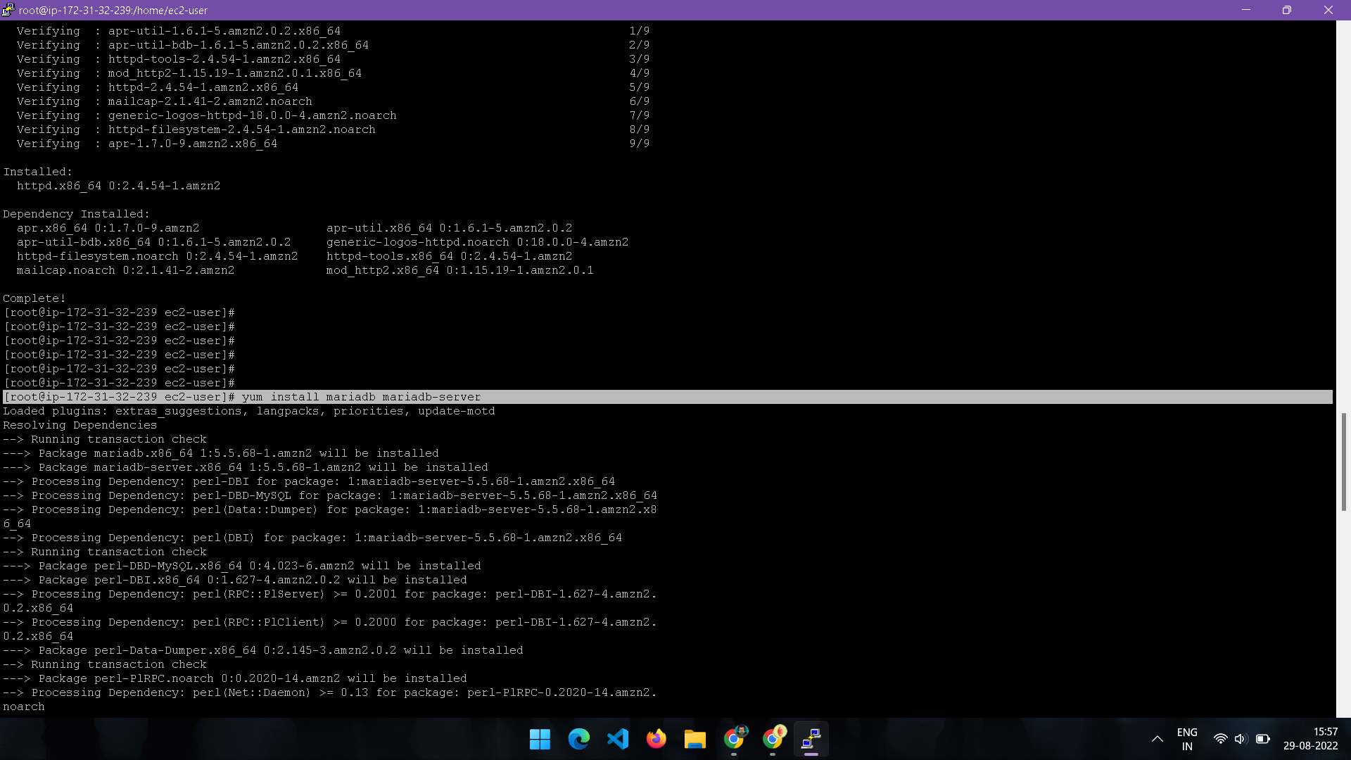

1. To install php, type “yum install phpphp-mysql”.

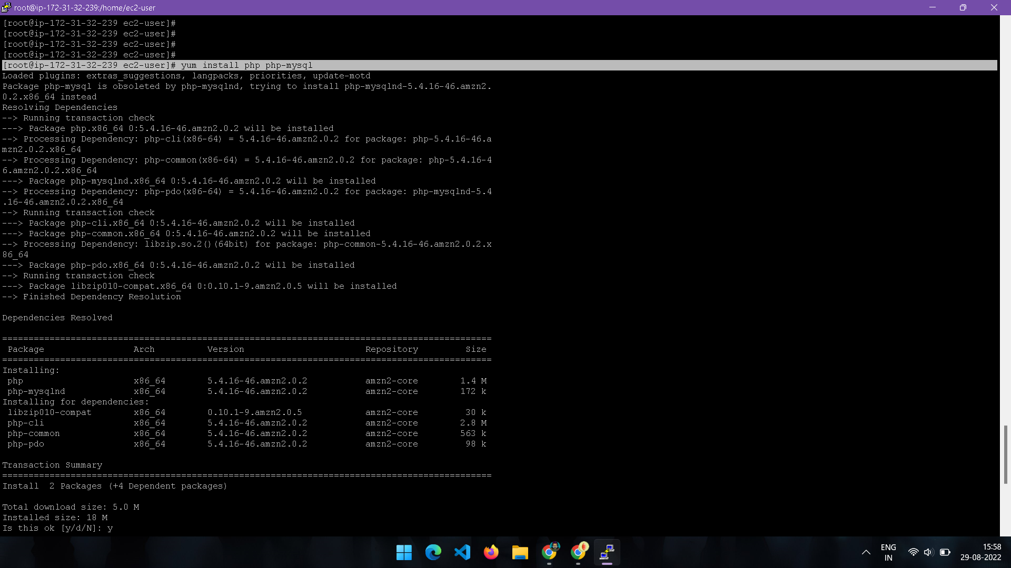

1. Type “yum search php” to see all the packages installed in the server.

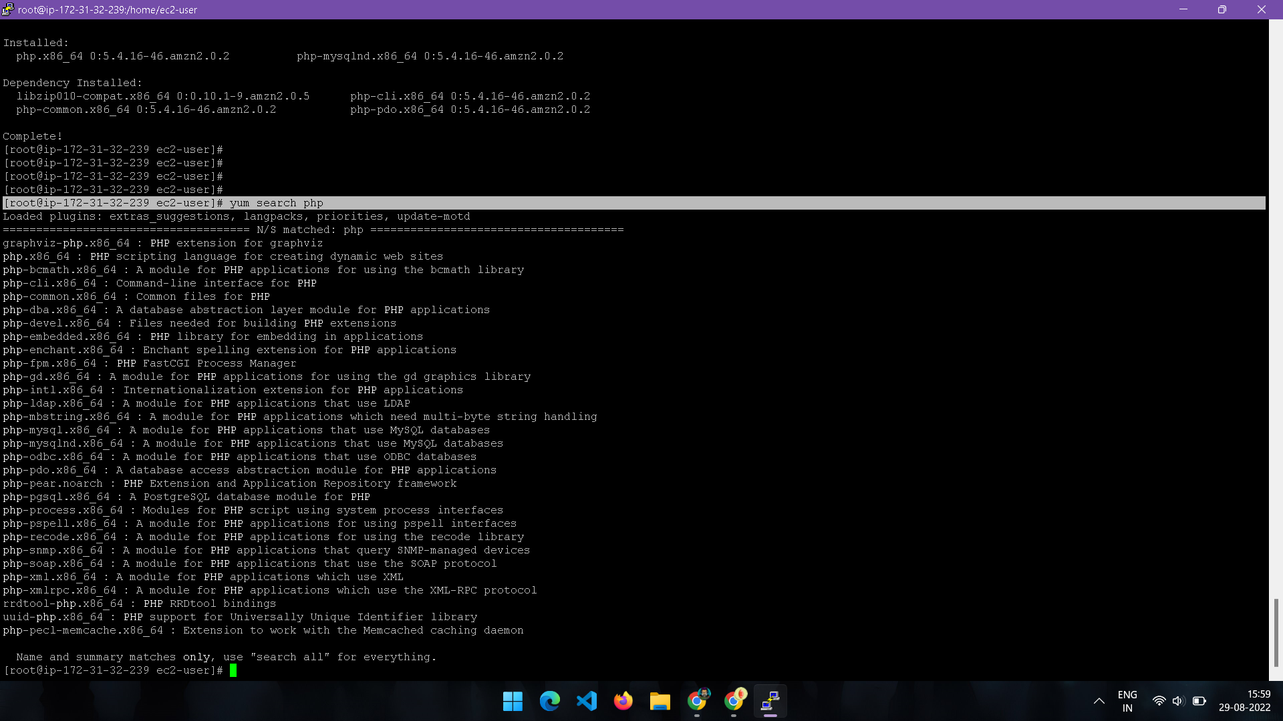

1. Enabling the mariadb server.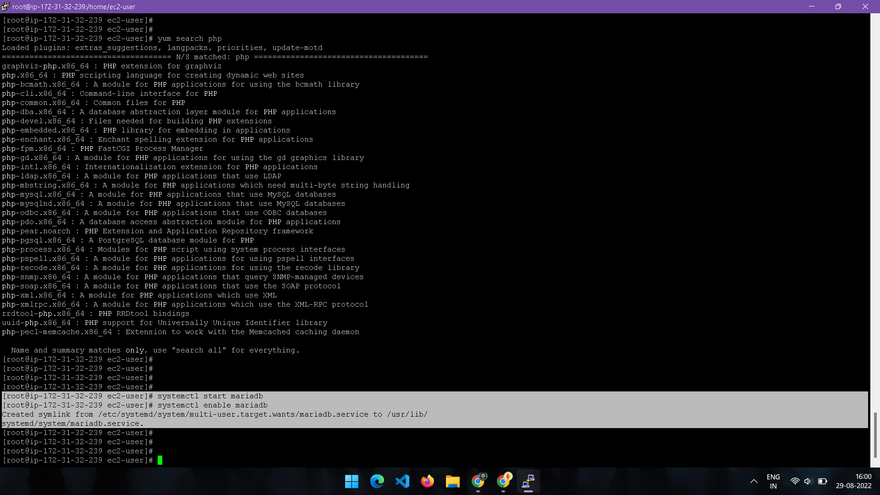
2. After enabling httpd (apache server) , go to the directory where cd /var/www/html/
3. Go to vim and type “<?phpphpinfo(); ?>”.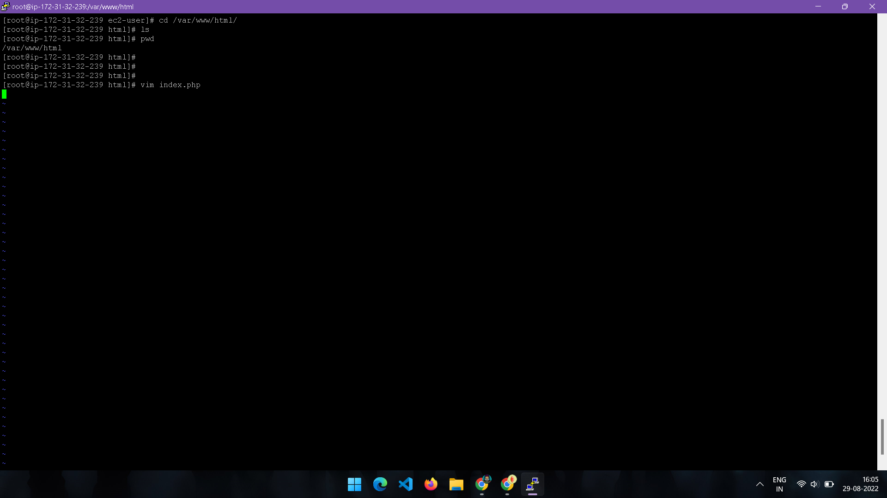

Copy the public ip address or public domain name from the console and paste in the web browser.

**OUTPUT:**

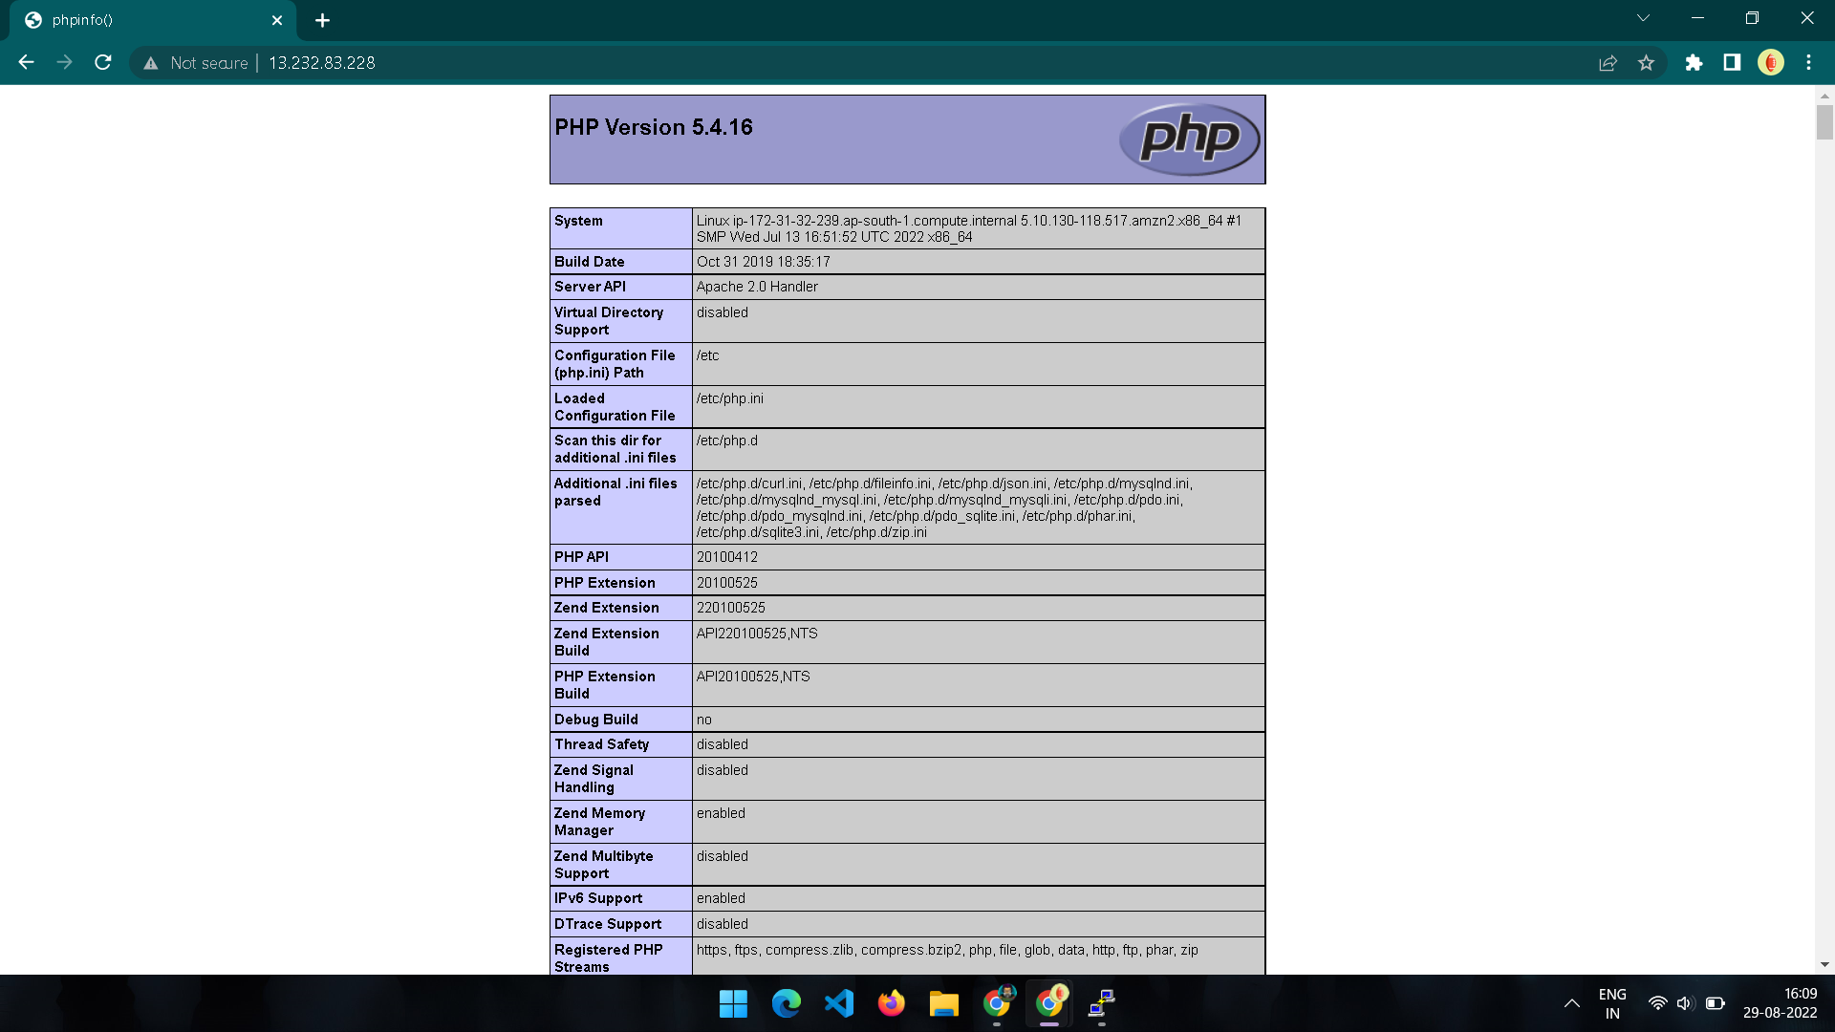

**RESULT:**

LAMP instance was successfully created and executed in AWS CLI.